Practical 1
Aim
To enable BIOS virtualization technology (Intel VT-x / AMD-V) and verify whether virtualization support is enabled on the host system.
Requirements
- A computer/laptop with Intel or AMD processor
- BIOS/UEFI firmware
- Windows operating system
Theory
Hardware virtualization allows a computer to run virtual machines efficiently by providing processor-level support for virtualization.
- Intel processors: Virtualization support is generally provided through Intel VT-x.
- AMD processors: Virtualization support is generally provided through AMD-V.
The virtualization setting can be enabled or disabled from the BIOS/UEFI settings. In Windows, its current status can be checked through Task Manager → Performance → CPU, where the Virtualization field shows whether it is enabled or disabled.
Procedure
Part A: Enter BIOS/UEFI Settings
- Shut down or restart the computer.
- During startup, use the dedicated BIOS shortcut Fn + F2 to enter the BIOS/UEFI setup.
- Once inside the BIOS, open More Settings.


- Navigate to:
Configuration → Intel(R) Virtualization Technology

Part B: Enable Virtualization
- Locate Intel(R) Virtualization Technology under the Configuration section.
- Change its setting from Disabled to Enabled.

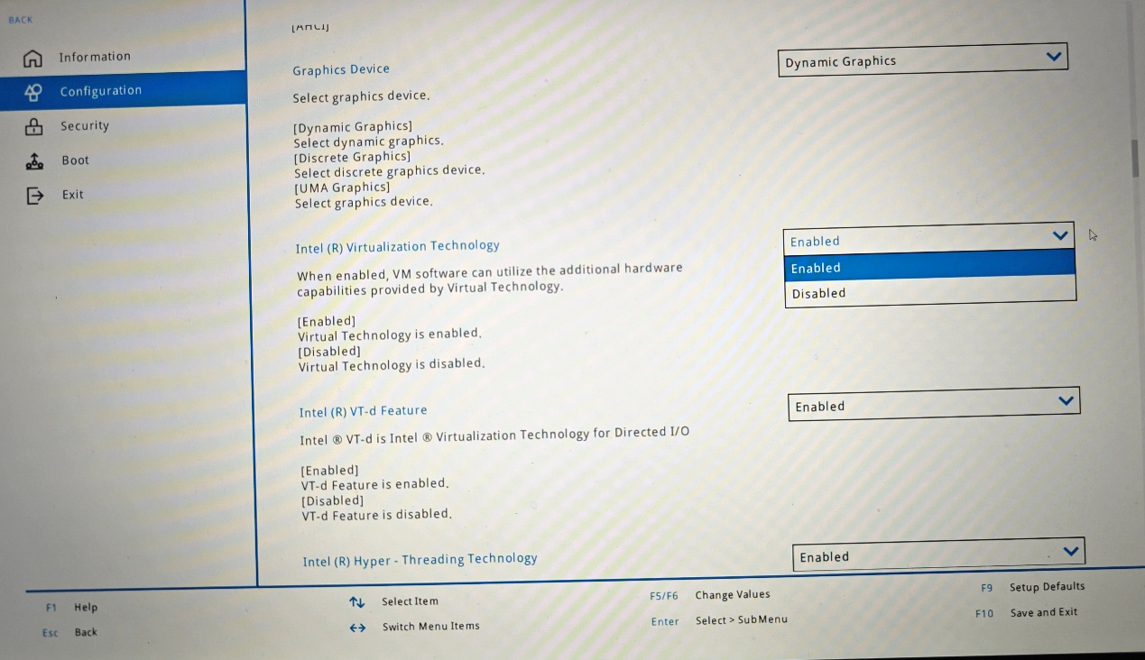
- Save the changes and exit the BIOS/UEFI settings.

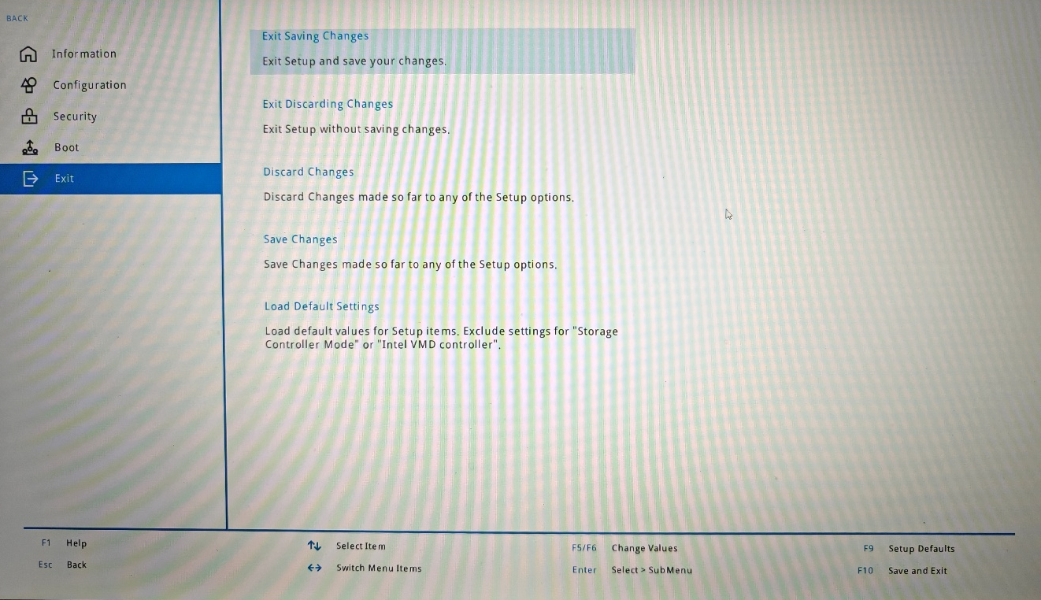
- Allow the computer to restart and boot into Windows.

Part C: Disable Virtualization
To disable virtualization, repeat the BIOS procedure:
- Restart the computer and enter BIOS/UEFI using Fn + F2.
- Go to More Settings.
- Navigate to:
Configuration → Intel(R) Virtualization Technology
- Change the setting from Enabled to Disabled.

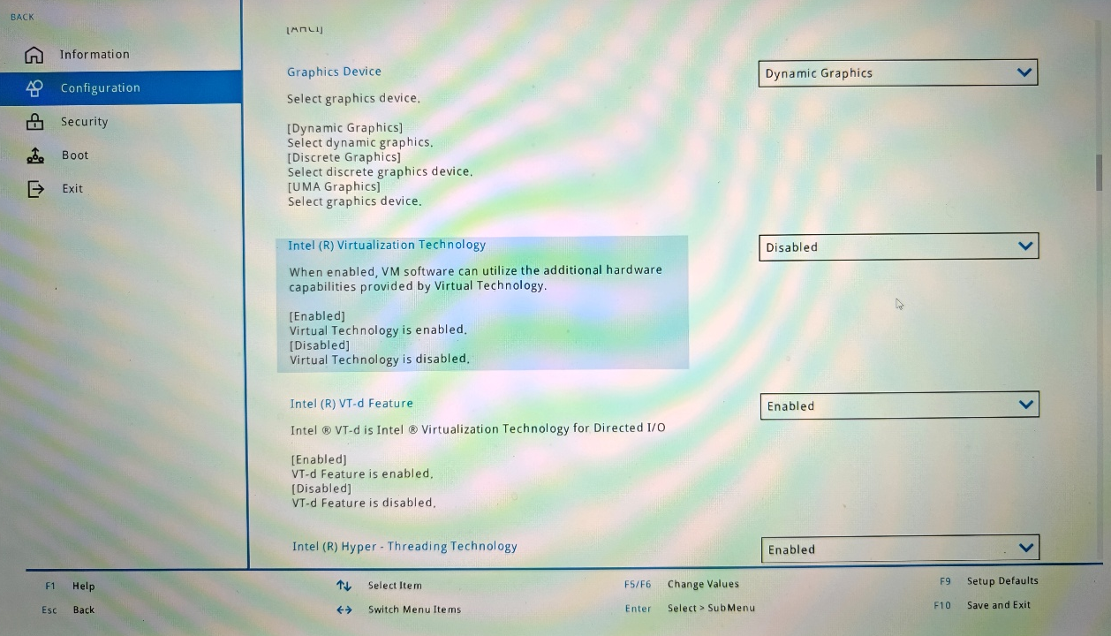
- Save the changes and exit BIOS/UEFI.
- The computer will restart with hardware virtualization disabled.
Note: The exact name and location of the virtualization option may vary between computers. On AMD systems, the option may appear as SVM Mode or AMD-V instead of Intel(R) Virtualization Technology.
Verification
After enabling virtualization:
- Boot into Windows.
- Open Task Manager.
  - This can be done by pressing Ctrl + Shift + Esc.
- Select the Performance tab.
- Select CPU from the left-hand panel.
- Look for the Virtualization field in the CPU information.

Expected Result
If virtualization has been successfully enabled, Task Manager should display:
Virtualization: Enabled
If virtualization has been disabled in BIOS, Task Manager should display:
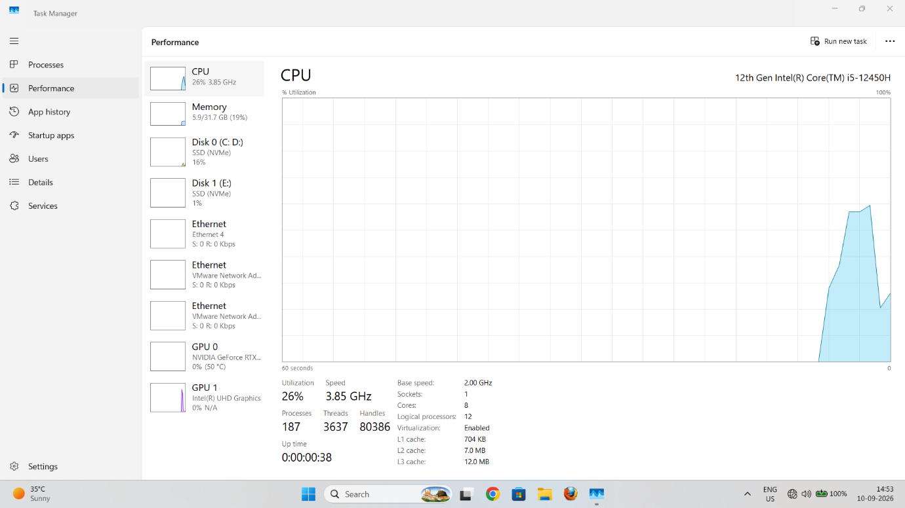
Virtualization: Disabled

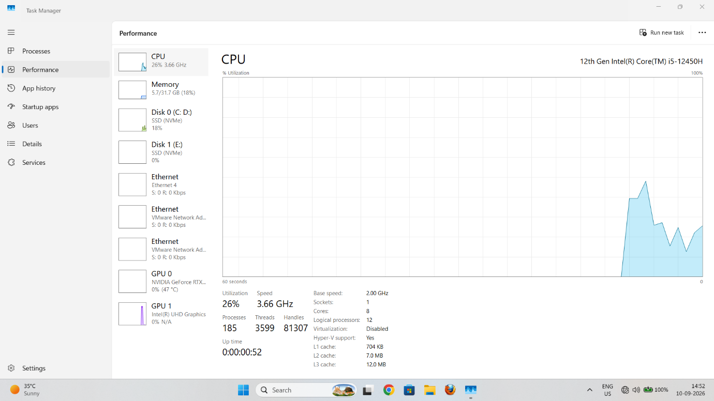
Observation
BIOS Setting | Task Manager → Performance → CPU
Intel(R) Virtualization Technology: Enabled | Virtualization: Enabled
Intel(R) Virtualization Technology: Disabled | Virtualization: Disabled
Result
BIOS virtualization technology was successfully enabled and its status was verified through Task Manager → Performance → CPU. The same procedure can also be used to disable the virtualization feature when required.
Conclusion
Hardware virtualization support can be controlled through the BIOS/UEFI firmware. For an Intel processor, enabling Intel VT-x / Intel(R) Virtualization Technology allows virtualization software to use hardware-assisted virtualization. Its status can be easily verified in Windows Task Manager.

